CME1001 Algorithms and Programming I
LAB 3

Exercises

1- Write a program that print the months of a given season.

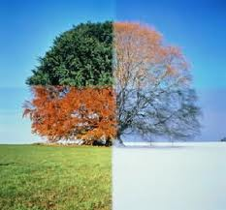
Example:
Input: Winter
Output: December, January, February

Example:
Input: Summer
Output: June, July, August

2- Write a program that takes an integer from the user and then determines it can be exactly divided by 7, or not.


Examples:
Input: 22 Input: 35 Input: 700
Output: False Output: True Output: True


3- Write a program that takes three integer values x, y, and z from the user, then prints true if the values are strictly ascending or descending (x < y < z or x > y > z), and false otherwise.

Example:
Inputs: x=3 y=5 z=8
Output: True

Example:
Inputs: x=7 y=9 z=2
Output: False

4- Write a program that reads the weight of a kickboxer (in kilograms) and prints out his weight class.

Example:
Input: 65
Output: Middleweight

Example:
Inputs: 110
Output: Super Heavyweight

Weight class name | Upper limit
Weight class name | in kilograms (kg) | in pounds (lb)
Lightweight | 63 | 138.9
Middleweight | 70 | 154.3
Heavyweight | 100 | 220.5
Super Heavyweight | No weight limit

5- Write a program that takes the time on a 24 hour clock, and converts it to the time on a 12 hour clock (AM/PM).

Examples:
Inputs: 9 30 (9:30) Inputs: 11 08 (11:08) Inputs: 17 12 (17:12)
Output: 9:30 AM Output: 11:08 AM Output: 5:12 PM

6- Write a program that prints the car license plate of given city which must be started with i character.


Examples:
Input: İzmir
Output: 35

Input: İçel
Output: 33

7- Write a program that determines whether the object with given three edges is a triangle or not.
a+b>c a+c>b b+c>a

a-b<c a-c<b b-c<a

Example:
Inputs: a=3 b=7 c=32
Output: It is not a triangle

Inputs: a=3 b=4 c=5
Output: It is a triangle
Questions

Upload the answers of the following questions from http://lectures.cs.deu.edu.tr web site until October 18, 2015.

1- Write a program that converts Turkish shoes numbers to ABD or UK shoes numbers.

Turkey | ABD | UK
36 | 6 | 3.5
37 | 6.5 | 4
37.5 | 7 | 4.5
38 | 7.5 | 5
39 | 8 | 5.5
39.5 | 8.5 | 6
40 | 9 | 6.5

Examples:
Inputs: 38 Inputs: 40 Inputs: 36 Inputs: 39.5
ABD UK UK ABD
Output: 7.5 Output: 6.5 Output: 3.5 Output: 8.5

2- Write a program that converts kitchen metrics (WaterGlass (WG), TeaCup, CoffeeCup, TableSpoon) to gram for the following foods.

Walnut (Ceviz) Milk (Süt) Wheat (Bulgur) Cocoa (Kakao)
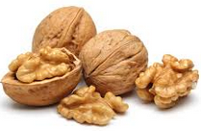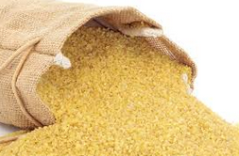

WG - WaterGlass (Su Bardağı)  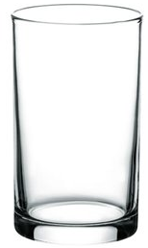 | TC - TeaCup (Çay Bardağı)  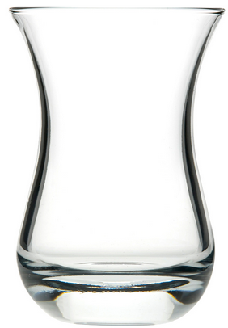 | CC - CoffeeCup (Kahve Fincanı)   | TS - TableSpoon (Çorba Kaşığı)  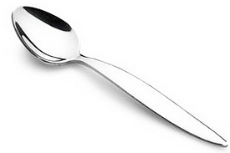

Note: Use the metrics in this web site - http://www.birimcevir.com/gida-olculeri/mutfak-birimleri.aspx

Examples:
Inputs: 8 Inputs: 40 Inputs: 5 Inputs: 2
WG CC TS TC
Walnut Milk Cocoa Wheat
Output: 800 gram Output: 3000 gram Output: 40 gram Output: 130 gram

3- Write a program that takes the current date and time in Turkey from the user and prints the date and time in Japon.

Note: Don’t use date and time commands in C# such as DateTime.AddHours(),AddDays, CompareTo(DateTime) etc.

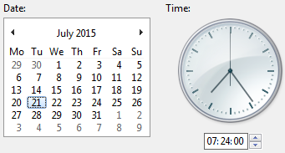
Examples:
Turkey 08/10/2015 10:24 AM
Tokyo 08/10/2015 04:24 PM

Inputs: day = 08
month = 10
year = 2015
hour = 10
minute = 24
PM
Output: 08/10/2015 04:24 PM

